**Troubleshooting update scripts**

**RM682**

**Some data sources updated**

Orth – common

Duded impact - gdb

Waterbody – Common

Flowline – Common

And othethes but non from wcgis

**But not others**

Hunts

Subunits



Oddly orig rm682 mxd is looking for wcgis in appdata

*C:\Users\jdmumm\AppData\Local\Temp\21\arcC567\898d40f83686b70393368a794452f345.sde\sde_wcgis_master.DBO.DWCMasters\sde_wcgis_master.DBO.DWCHunts*

Broken ss doesn’t have any *C:\Users\jdmumm\AppData\Local\Temp\21* files, only …\Temp\16, including this near mtch

*C:\Users\jdmumm\AppData\Local\Temp\16\arc6107\898d40f83686b70393368a794452f345.sde\sde_wcgis_master.DBO.DWCMasters\sde_wcgis_master.DBO.DWCHunts*

*Line 382*

Manually edited highlighted above in out.csv and worked to fix hunts path

Trouble is running the brokenlink tool the next day I get this as the broken link:

*C:\Users\jdmumm\AppData\Local\Temp\25\arcFA54\898d40f83686b70393368a794452f345.sde\sde_wcgis_master.DBO.DWCMasters\sde_wcgis_master.DBO.DWCHunts*

… and then a few minutes later copying the mxd to a new folder I get this: C:\Users\jdmumm\AppData\Local\Temp\27\arc1786\898d40f83686b70393368a794452f345.sde\sde_wcgis_master.DBO.DWCMasters\sde_wcgis_master.DBO.DWCHunts

Running again in same folder, broken path stays the same ie temp27\arc1786

Running again on copy in the same folder path stays the same : 27

Copying from network to local and running again a few minutes later still 27

But after resigning into windows changes to 29

C:\Users\jdmumm\AppData\Local\Temp\29\arcC4C8\898d40f83686b70393368a794452f345.sde\sde_wcgis_master.DBO.DWCMasters\sde_wcgis_master.DBO.DWCHunts

Soloutions:

Incorporate wildcards into script

11/6/20

Is it only a problem for those pointing to sally’s obsolete version?

Try again with rm682 – do one of the two hunt layers work?

A – The other hunt layer is default and wasn’t broken to begin with.

Why didn’t subunits get fixed.

Codes messed up on inventory workingfor codes 149 to 156

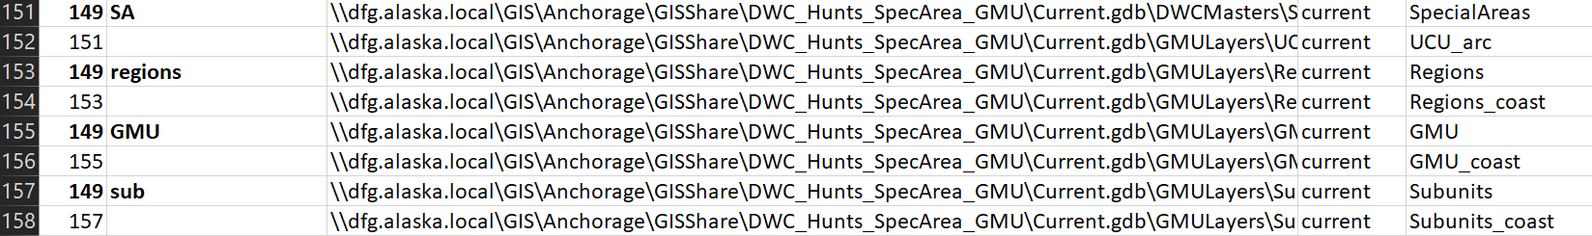

Fix it inventory, then on broken

Review where code 149 was used

